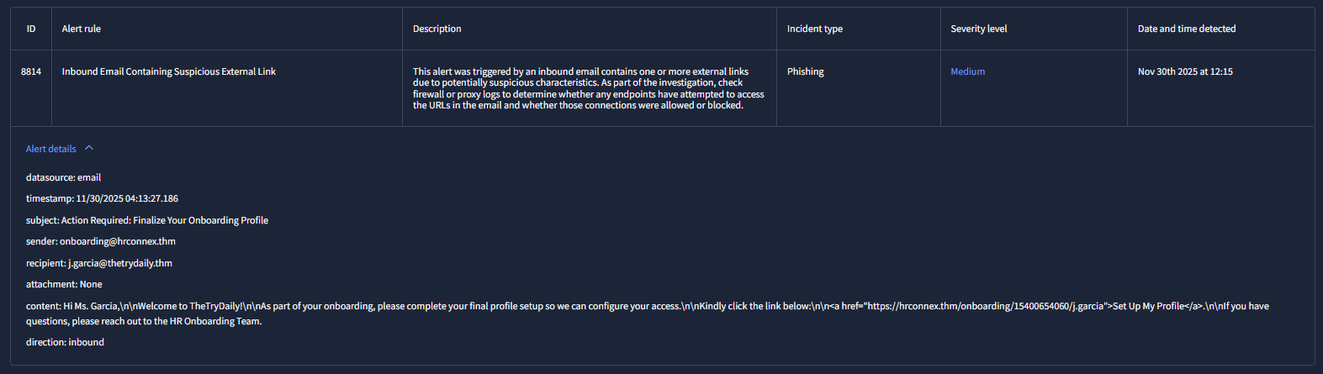

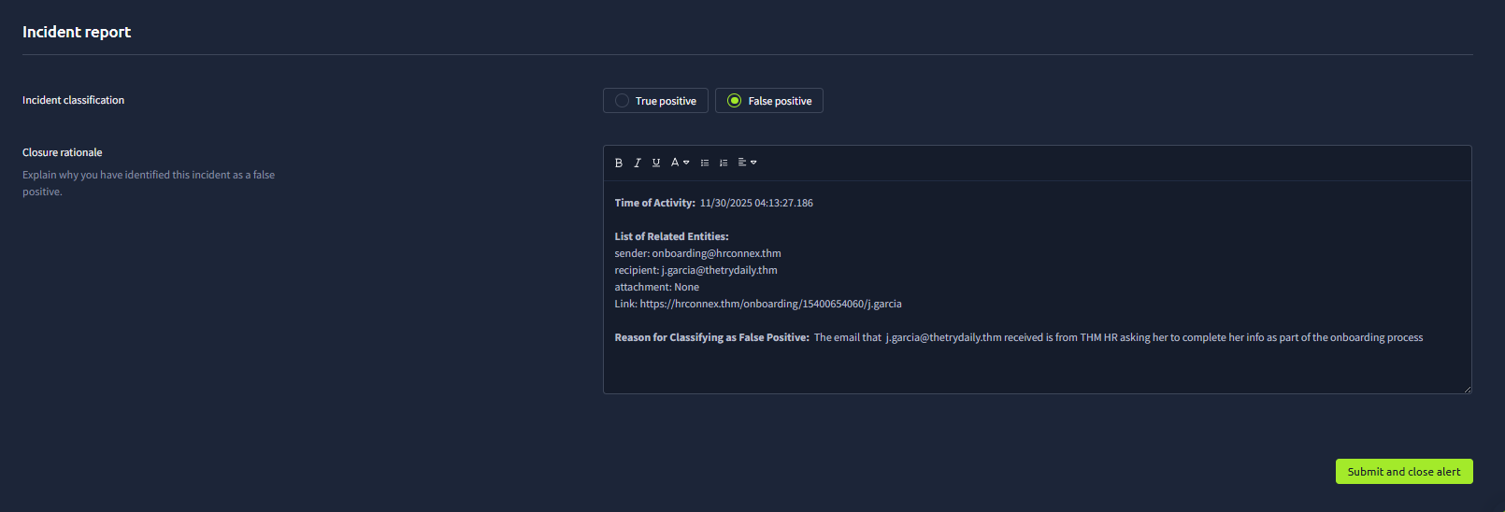
Complete IR:
Time of Activity: 11/30/2025 04:13:27.186

List of Related Entities:
sender: onboarding@hrconnex.thm
recipient: j.garcia@thetrydaily.thm
attachment: None
Link: https://hrconnex.thm/onboarding/15400654060/j.garcia

Reason for Classifying as False Positive: The email that j.garcia@thetrydaily.thm received is from THM HR asking her to complete her info as part of the onboarding process

